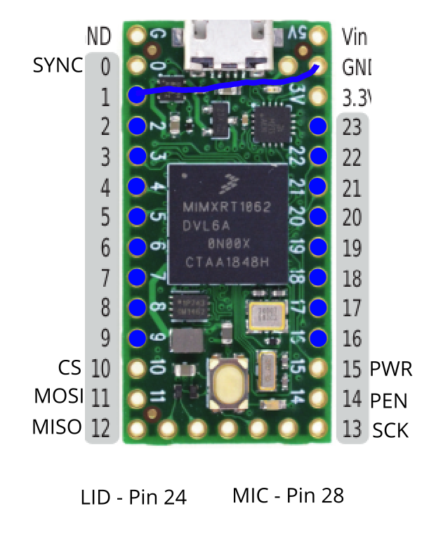

All blue pads are the pads connected to the Input Interface flex-cable. I have tested every pin except for MIC, which I connected but most likely don’t plan on using.

I used a Teensy 4.0 on this build, ask me if you want more photos of my build.

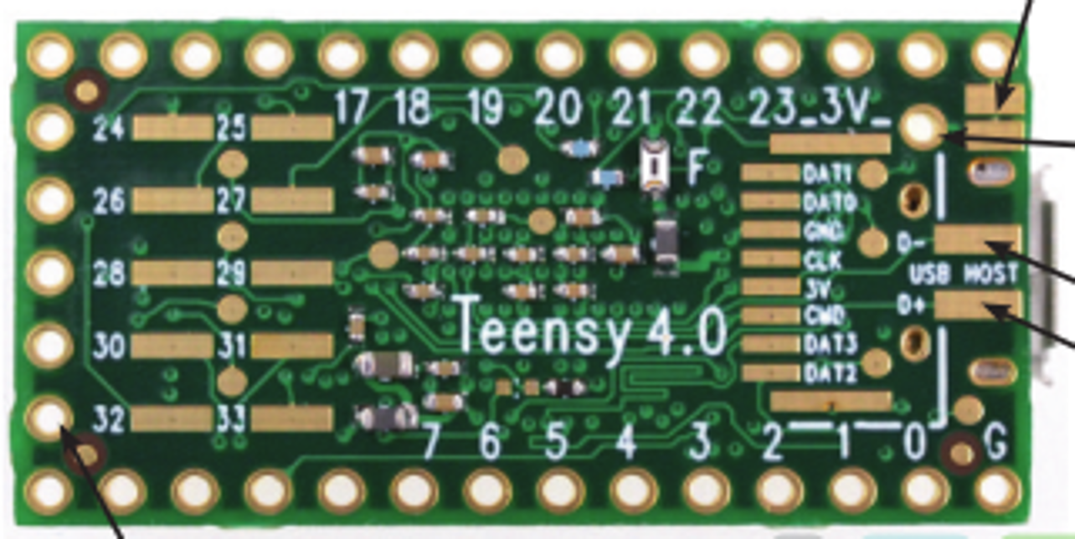

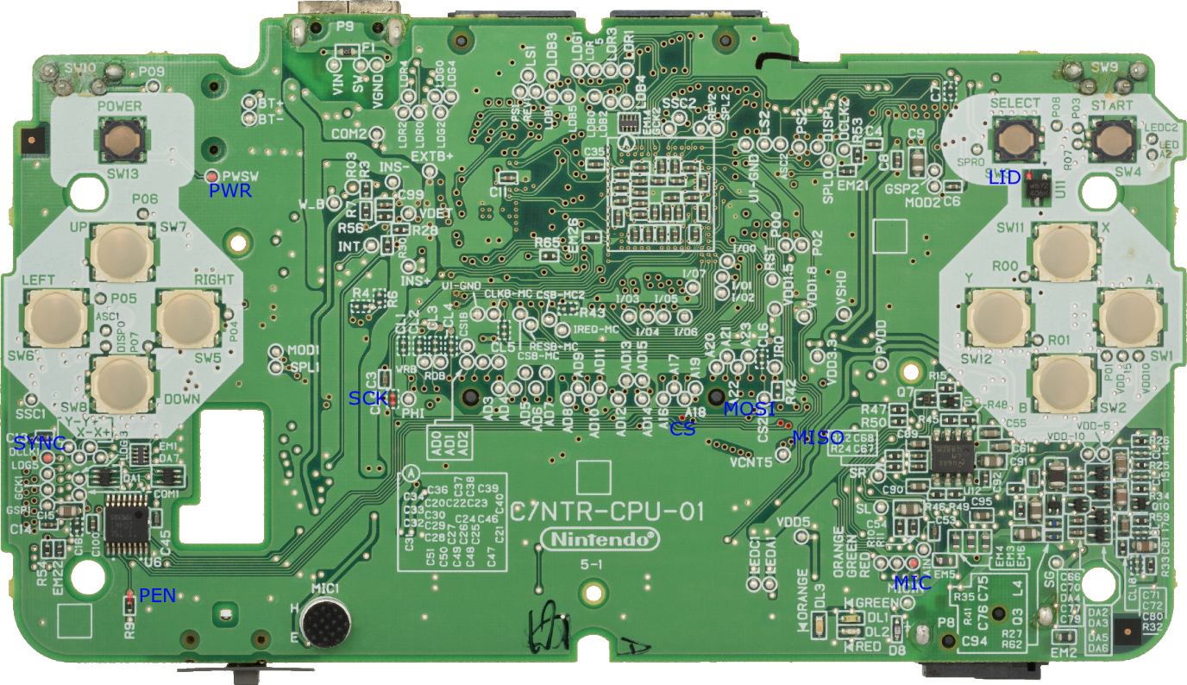

These are the locations of all of the pads on the DS motherboard that are used excluding those that are connected with the input interface flex cable. I recommend using thin wire to ensure everything fits.